Shabbos Stories For
parshas chaya sarah 5785
Volume 16, Issue 9 22 Cheshvon 5785/November 23, 2024
Printed L’illuy nishmas Nechama bas R’ Noach, a”h
For a free subscription, please forward your request to keren18@juno.com
Past emails can be found on the website – ShabbosStories.com

The Pipeline for Blessings
By Rabbi David Sutton,
Adapted by Leah Sutton

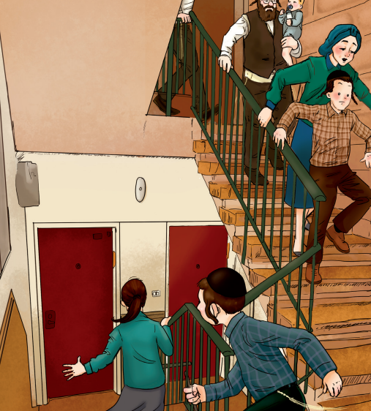

The war in Eretz Yisrael was frightening. Every day, the Arabs would launch missiles at the Jewish people. A siren would go off, warning everyone that a missile would soon land in the area. Everyone would run to find a nearby shelter. Almost every apartment building in Eretz Yisrael had a cellar where all the families would gather in case of missiles or bombings. There, they would wait until they heard another siren signaling that it was safe to come out. Some people brought their radios with them to hear what was going on.
It was a bright, sunny day in Yerushalayim when the sirens went off. “Hurry, hurry!” young Yaakov Adler told his sister Chaya Esther. “We have to go down to the basement!” People were running all around and parents kept checking to make sure that all their children were with them.
“A missile just hit the gas line!” the radio announcer said.
“Oh, no!” Yaakov’s father exclaimed. “That will cause a fire in the entire neighborhood!”
One man started saying Tehillim out loud and everyone followed him. Some adults even started crying.
“I’m so scared,” Chaya Esther said to her mother. Her mother gave her a tight hug.
“Hashem will protect us, Chaya Esther,” she said softly. “We must have bitachon. Come, let’s daven together.”
Before long, all the girls joined Chaya Esther and her mother. They had so much kavanah that they almost didn’t realize when the siren signaled it was safe for them to come out.
“No pushing,” one man said to the children who were trying to get out quickly. Everyone wanted to see where the missiles had fallen and what was destroyed.
As they opened the door of the cellar, they blinked their eyes. They weren’t used to the sunlight after being in the dark shelter for so long. Suddenly, a man ran toward them. “Rabbi Adler, you’re not going to believe this!”
“Is it good news?” Rabbi Adler asked hopefully.
“Just listen,” the man said excitedly. “While we were all in the shelter, a missile hit the main gas line.”
“Yes, we heard. What damage was there?”
“Nothing much!” the man said. “Right after the missile hit the gas pipe, another missile came, and guess what it hit? The water pipe!” he said, answering his own question.
Rabbi Adler was in shock. “You mean…”
“Yup, that’s exactly what I mean,” the man said, smiling widely. “When the gas line got hit and a fire broke out, the water line got hit, and put out anything that was on fire.”
Rabbi Adler lifted his eyes. “Thank You, Ribbono shel Olam,” he cried.
“But Abba,” Chaya Esther said, tugging on his jacket. “If Hashem wasn’t going to let there be a fire in the first place, why did any of the pipes need to get hit at all?”
“Excellent question, Chaya Esther. Hashem wanted us to see that He is taking care of us. Look, we are all so grateful right now. If none of this would have happened, we wouldn’t feel the same gratitude and love toward Hashem that we feel now, after seeing how He protected us.”
Sometimes we might be in a situation that makes us scared or nervous. Maybe your baby brother is missing! You daven very hard that he should be found. Soon, you see him sleeping in your closet! You might wonder, why did Hashem scare me for no reason?
But maybe it’s not for no reason. Maybe there was a good reason. Maybe the reason is that Hashem just wanted to remind you of how much He loves you. You would have never thought about that if nothing was out of the ordinary.

Reprinted from the Rosh Hashanah 5785 edition of At the ArtScroll Yom Tov Table. Excerpted from the ArtScroll book – “Living with Bitachon for Children.”

Greatness Around Us

Rabbi Y.Y. Jacobson

Rabbi Yosef Yitzchak Jacobson tells a story that a young man shared with him. Growing up this boy had a hard time staying still in class, and school after school would tell him not to return. Exasperated, the boy’s father would punish the boy harshly in hopes that the boy would correct his actions. After the eighth school expelled his son, the father sent him to Israel because he could not deal with his son anymore.
Alone, the fourteen-year-old boy goes into the empty Slonimer shul in Bnei Brak where he sees a 95-year-old Jew davening. Little did this boy know that that was Rebbe Usher Arkovich. When he was done davening, the old man questions the young boy if it was late in the day, why he was not in school?

The boy, embarrassed replied, “I haven’t had luck in any school system. I was expelled from school after school, eight in all. My father sent me off to Israel. I am forlorn.”
The Reb Usher looked at the boy and said,” You know we say every day in Ashrei: ‘Lehodia livnei ha’adam g’vuratav u’chvod hadar malchuto—Hashem wants to tell people about His own strength and His own royalty.’ The great Chassidic master, the Maggid Lechovich gave another interpretation to this passuk. Hashem wants us to talk about His wisdom and strength so that we should tell a person of his strengths. Teach every person you meet his own strengths, glory and holiness.
G-d does not need our praises. When we list Hashem’s praises, we recognize Hashem’s ultimate wisdom and power. If G-d is perfect that means He did not make a mistake when creating you. Your creation is testimony that Hashem was making a statement by putting you in this world. The world is not complete without this person’s contribution! It is a mitzvah to make every person you meet aware of their g’vuratav—strengths. Whatever happens, never forget your own power.”
After six months later this boy was expelled again. He finally got into a tenth Yeshivah a half a year later he was asked not to return. At fifteen yours old, the boy was rejected from ten schools, and he had no father to call. He felt so alone, lost and broken from the world that he decided he would end his life. He climbed a tall building in Yerushalayim and paced on the edge of the roof about to jump to take himself out of his agony.
Suddenly, he had a flashback to the conversation he had with that 95-year-old man, Rebbe Usher Arkovich. He decided he would have to make himself aware of all his strengths before he could make the decision to end everything.
He climbed down from the building, got his life together, got married with kids, and built a successful business. Could Reb Usher have known that the impact of his words would save a young life from suicide. Do not be stingy with your words, embraces and compliments. Every soul is a manifestation of G-d in this world. Let every person you meet know about their strengths, beauty and amazing gifts.
As Rosh Hashanah approaches, may we all praise Hashem loudly for His miracles and kindness, both big and small. May we all take advantage of the great opportunity that Hashem is giving us for another year of life and sustenance. Let us also say thank You and be happy with all the blessings that Hashem bestows upon us!

Reprinted from the Parashat Ki Tavo 5784 email of Jack E Rahmey based on the Torah teachings of Rabbi Amram Sananes.

Stories of Faith
The Old and Young
Wagon Drivers
By Rabbi Elimelech Biderman

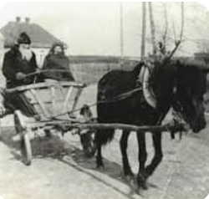

There was once a baal agalah (wagon driver) who served his town loyally for many years. But he was getting old and couldn’t keep up with the demand, so the townspeople decided it was time to train a new wagon driver to take his place.
A strong, young lad was chosen to become the new wagon driver. The old wagon driver was insulted. He worked for so many years as the town's wagon driver, and now a young man was taking his place. He said, "I will test the new wagon driver and see whether he is fitting for the job. If he passes the test, I will graciously hand the reigns over to him. But if he can’t answer my questions, he isn't fitting for the job and I will keep my post."
The old man asked the young man, "What will you do if your wagon gets stuck in the mud?"
The lad replied, "I will get off the wagon and push the wagon until it gets out of the mud."
"What will you do if that doesn’t help?"
"I will tell everyone to get off the wagon and help me push it out of the mud."
"And if that doesn’t work, what will you do then?"
"I will unload the packages to make it easier for the horses, and we will try again."
"And if that doesn't work, what will you do?"

The Lad is Stumped by the Questions
The lad thought for a moment and admitted that he didn't know.
"Then you are not worthy of the position."
The lad humbly accepted the rebuke but he still wanted to know the answer. "Please tell me; what should one do if the wagon is stuck in the mud and can't get out?"
The old wagon driver looked athim and replied, "An expert wagon driver stays out of the mud in the first place."

The Connection of Mud to Sins
The lesson is that after one falls into sins, it is hard to get out. Therefore, one should take every precaution not to fall in the first place. But if he did fall into the quagmire of sins, and even if he has accustomed himself to sin, he should keep trying until he succeeds to do teshuvah sheleimah.

Reprinted from the October 10, 2024 email of Torah Times Media.

House Arrest
By David Koppelman

In the Russian town of Brazdiuv lived an old man by the name of Reb Zalman Lichtzier. He was a professional mohel, a rarity in the Soviet Union in the 1960s. Although the government had forbidden the ritual of circumcision, Reb Zalman let it be known that he was willing to ignore the decree and circumcise any Jewish child that was brought to him. Old as he was, he felt he did not have much to lose by defying the government, for the worst they could do was execute him, and he had already lived a long and full life.
Word of this dedicated mohel spread among the Jews, and from near and far they secretly brought him their baby boys. Reb Zalman circumcised them all, and refused to accept payment for his services.

The High-Ranking Officer with a Shotgun
One day a “natchalnik,” a high-ranking officer, armed with a shotgun, showed up on Reb Zalman’s doorstep. Reb Zalman invited the officer into his house, sure that he was about to be arrested. Instead, the officer said, “I, too, am a Jew. My wife, who is also Jewish, has recently borne me a beautiful son, and we would like you to perform his berit milah.”
Reb Zalman was struck dumb. But he did not have to answer yet, for the officer was still explaining the situation.
“It is forbidden for you, obviously a Jew, to enter my home. If you were to be seen, both of our lives would be in danger. Therefore, I worked out the following plan: You will try to cross the border at a place I will designate, without a passport. You will be arrested and brought to me, for it is my job to deal with illegal border crossings. At that point I will take you to my home, and you will perform the berit there.”

Was this a Diabolical Trap
Was the officer speaking the truth, or was he trying to ensnare Reb Zalman in an elaborately set trap? Reb Zalman did not know. “I have taken upon myself to perform the misvah of berit milah with absolute mesirut nefesh,” he thought, “and so I will take a chance and follow the officer’s instructions, although I may be risking my life.” He hoped his decision was the right one.
Reb Zalman acquiesced to the officer’s plan. He took a valise and packed his talet, tefillin, and the instruments he would need for the milah, and traveled towards the agreed-upon border point. According to plan, he was arrested, admitted to not having a passport, and then taken directly to the Jewish officer who had come to see him. The officer, playing his part to perfection, angrily yelled that he would punish the Jew as he deserved. As soon as the arresting officer left, the “natchalnik” seated Reb Zalman in his car and drove him to his home.
The berit milah was carried out according to halachah, and after it was all over, the officer drove Reb Zalman back to Bradziuv, where he continued to perform his secret misvot. (Glimpses of Greatness)

Reprinted from the 5785 email of Rabbi David Bibi’s Shabbat Shalom from Cyberspace. Excerpted from the 1994 Gefen book – “Glimpses of Greatness.)

Ben Adam LeMakom

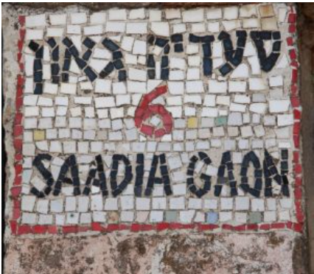
Number 6 Saadia Gaon Street in Jerusalem

Rabbi David Ashear told a story in Living Emunah 2 about Rav Saadia Gaon, who would make a point to seclude himself in a private room for 20 minutes daily. One day, a student, overcome with curiosity, went into his Rabbi’s private space and hid in a closet. The Rabbi came in and proceeded to lower himself to the floor, crying, “Chatati, aviti, pashati lefanecha – I have sinned before You….” The student could not understand why this great Rabbi could possibly cry for forgiveness and do such an intense teshuvah daily.
The student approached his rabbi and confessed to having watched him. “Why do you beg Hashem for forgiveness every day in such an intense fashion?” He asked.
Rav Saadia explained that once on his travels, he stopped at the home of a very kindhearted Jew. The host was generous and hospitable, offering the Rabbi meals and a room. When morning came, Rav Saadia warmly thanked him and went on his way.
Suddenly, a few minutes later, Rav Saadia saw his host running after him, throwing himself on the floor and begging the Rav for forgiveness. The Rabbi inquired, asking why he was so upset when the host provided such generous hospitality. The host cried, “I did not know you were the Great Rav Saadia Gaon. I would have shown you so much more respect and honor.”
The Rabbi explained to his student, “Each day, I find out something new about the greatness of Hashem, and I become filled with guilt. I would have served Hashem with much more respect and care if I had known. So, each day, I have to beg Hashem for forgiveness, for not treating Him properly the day before.”

Reprinted from the Yom Kippur 5785 email of Jack E. Rahmey based on the Torah teachings of Rabbi Amram Sananes.

The Difficult Commitment

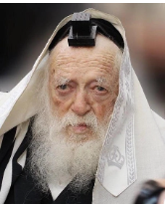
Rabbi Chaim Kanievsky

Once as Rav Avraham Yishayahu Stern and his family were traveling to Bnei Brak for a wedding, they decided to visit Rav Chaim Kanievsky, Z”TL. When there, he asked Rav Chaim for a bracha for his son who has been struggling to have a child. Suddenly, in Rav Chaim’s classic manner, he picked up his holy eyes and gazed deeply into his son’s eyes for three minutes straight as if he was glancing into his soul. When Rav Chaim exited his trance-like state, he asked, “Are you willing to pay?”
Rav Avraham said, “Of course.” Rav Chaim then asked, “Are you willing to pay by learning the entire Talmud?” He responded, “Yes.” Rav Chaim then took his two hands into his hands, returned learning for a minute, raised his eyes, and asked, “Are you willing to learn the entire Talmud in nine months to have a child?” The father asked, “If he does that does the Rav promise that he’ll have a child?” Rav Chaim said, “Yes.” Courageously, the father said, “I’ll do it.”
Rav Avraham began intensively learning as he had to complete over twelve pages a day for nine months. About a month later, Rav Avraham went to America when his son called to inform him that, at long last, he was having a baby.
Reprinted from the Rosh Hashanah 5785 email of Torah Sweets.
Moving My Parents
By Chaya Rochel Zimmerman



My family was the only thing left behind.
When the last truckload, crammed with boxes of prayer books, stacks of chairs, and the four-foot-tall wooden dais, drove away, my father locked the doors of the synagogue as he had done for the past nine years.
Our beloved synagogue had opened its doors in 1913 on Staten Island, New York and now, in 1972, stood empty, except for a faint flickering on the wall of muted colors streaming through the stained-glass window. The Polish, Italian and Jewish immigrant families, who had inhabited my once thriving childhood neighborhood, had moved away when the streets gave rise to rough and rowdy teenagers playing loud music late into the night.
My elderly father worked hard to own his home and never thought about moving, nor of giving up his job as the physical and spiritual caretaker of the synagogue, a position he inherited upon the passing of my grandfather.

At the Age of 68 My Father Began Walking Two
Plus Miles Through a Now Dangerous Neighborhood
The synagogue purchased another building much further away to continue servicing its aging congregants. So, at the age of sixty-eight without any complaints, my ever-conscientious father, began walking the two plus miles back and forth on Shabbos and the holy festivals through the now dangerous neighborhood.
Although my father’s sweet smile and sincerity could melt anyone’s heart, my mother and I feared for his life. Within a few months, my small father was mugged twice, each time explaining to some tall dark man that it was the Jewish Sabbath and he didn’t have any money or cigarettes on him. Mercifully they let him go.
I decided it was time to move. I was twenty-one, in college, and the only child living at home; my brother had made Aliyah the year before and my married sister was busy with her two preschoolers.

Began Packing for a Move to Another
Home as Yet Not Determined
I started packing, not sure yet where we would move to. “What are you doing?” said my father alarmed. My mother stood nearby in silent agreement, but helpless to verbalize it.
“It’s time to move,” I said. “This is my home.”
“I know. I’ll find you another home. It’s too dangerous for you to walk home on Shabbos.” “I’m not moving.”
We had both walked these streets for years in safety, but now it was time to admit, it had changed. Torah commands us not to not put our bodies in danger, lest our souls leave this world. I continued working.

Do Piles of Yellowed Yiddish
Newspapers Count as Being Valuable?
I gathered, sorted, packed and discarded. This last category ended in deadlock. My attempts to throw out what I considered worthless and what my father considered priceless, threatened the whole move. Do piles of yellowed Yiddish newspapers from the last twenty years count as valuable? Or extras of old weekly synagogue bulletins, or unread catalogues that came through the mail?
It would be impossible to fit everything they owned into a small rented apartment, so I continued working against the rising resistance of my father who refused to allow me to dispose of the growing bags of garbage before he sorted through each one. This wasn’t just a matter of elderly clutter or hoarding. I was disregarding his core beliefs that ran generations deep.
My father was a European product, born in Lomazy Poland, and had lived in Biala Podlaska, Berditchev, the Bronx, the Lower East Side and Staten Island. Moving was not new to him. He had lived through WWI in Europe and the Great Depression in America and it pained him to see anything usable destroyed or disposed of. The wrinkles on his balding forehead deepened as he paced the floor, watching me continue to sift through the layers of his life. His agitation increased as the pile of moving boxes grew. It was a matter of trust.

The Goal was to Lengthen the Days of Her Parents
My true intentions were to uphold the fourth commandment, “To Honor and Fear Your Mother and Your Father So You May Lengthen the Days of Your Life”. I wasn’t sweating this backbreaking task to lengthen the days of my years, but to lengthen their days.
It also pained me to leave behind the place that held my childhood memories: reading a good book leaning against the tree heavy with peaches surrounded by the tall uncut grass we hid in when we played hide go seek, sitting on the steps of the wooden front porch sharing childish secrets with my friends, playing kick ball with my brother inside the house where the Angel of balls ensured that nothing ever broke, celebrating my good marks after studying with my mother at the kitchen table, smelling my mother’s eggplant roasting atop the gas fire.
The Torah equates the honor and fear of one’s parents with the honor and fear of G-d himself. Rambam explains that to fear your father means not to contradict his word nor offer an opinion that outweighs his. I felt I paid a high price for not respecting my father’s wishes, but surely moving was his inner wish.

Finding a House Just Two Blocks from the New Synagogue
My mother and I searched for an apartment in vain, until my aunt came to town at the last hour. She was my father’s only sister, twenty-one years his junior, born in America, and he loved her dearly. My aunt, with my sister’s help, found a house for rent two blocks from the new synagogue location and ordered a moving van.
Eventually, my father blessed me for moving him, forever grateful to be close to the synagogue. However, he remained troubled over the things I had disposed of in the moving process, that he felt still had value.
Although I had the noblest of reasons for moving my aging parents, it’s not a decision to be taken lightly.

Reprinted from the Parshas Haazinu 5784 edition of L’Chaim. Chaya Rochel Zimmerman, is the author of: Lemons in the Fog, The Next Pair of Shoes and Seattle to Strawberries / You can contact her through: zimnovels.com
Defining True Ahavas Yisroel
By Rabbi Sholom DovBer Avtzon

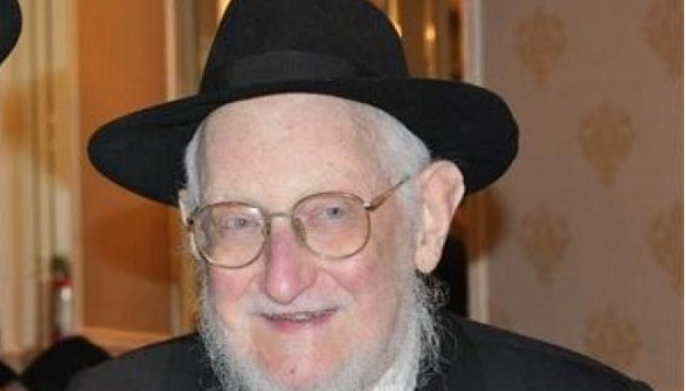
Rabbi Sholom DovBer Goldshmid of blessed memory

Rabbi Sholom DovBer Goldshmid was a bochur in 770 and he would seek the Rebbe’s guidance in many aspects of his life. This was especially so when he came to the stage of shidduchim, he turned to the Lubavitcher Rebbe for guidance. Being that in those years there weren’t that many chassidim, it was easy to have a yechidus (personal audience) with the Rebbe, and this was especially so for the students of the yeshiva in 770.
During one yechidus the Rebbe told him that Ahavas Yisroel is giving a Jew something they want, and this applies to every Jew, male or female.
At that point he had no idea what the Rebbe was referring to, but he knew that if the Rebbe mentioned it, it is an important aspect that he should act on it when he has that opportunity. To him it wasn’t a question of if, but of when he would be called on to fulfill that directive.
Sometime later, Rabbi Hodakov [the Rebbe’s personal secretary] called him into his office and said that he would like to propose a young lady to him. He then informed him of her name, adding that she is a niece of Rabbi Yosef Weinberg.

Getting Advice from the Lubavitcher Rebbe
They met, and after some time they both were ready to become engaged, but he informed her that although he is ready, he first would ask the Rebbe for his opinion.
The Rebbe replied that it is an appropriate match, and then added, that if you would want me to be mesader kiddushin(officiate at the wedding), as is known, that I will only do so if the bride will wear a wig after the marriage.
When he mentioned this to her, she replied that a wig is befitting old women; it is not for me! [It should be noted that very few Orthodox women wore wigs in the early fifties]. Although he didn't argue with her or say anything negative, she noticed an expression of unhappiness on his face. Rabbi Weinberg also noticed it, and without her noticing, he hinted to him that he will talk to her and try to convince her to put on a wig.

The Girl was Very Upset
However, she was strong in her opinion and didn't feel that it is necessary to wear a wig and restated her decision that she wouldn’t. Yet at the same time she believed that her uncle discussed it with her on behalf of her chosson, and being that he was so disappointed that because of her refusal, the Rebbe wouldn’t officiate at his wedding, he would break off the engagement. So, she poured out her heart out to her uncle and said that she would like to speak to her chosson.

She Felt as Though She Had Lost Her Chance for Her Own Dignity
Sholom Ber came to the house, and she said to him, “In Poland I lost both of my parents and I felt like a nobody, a shmatte (a rag). Finally, my uncle was able to contact me and took me into his house, and I was looking forward to the day that I would be independent and have my own dignity, and not be a burden to anyone. Now that you are disappointed that the Rebbe won't be mesader kiddushin, and the shidduch will be broken, I will lose my chance for my own dignity and will be a rag once again.
“Why are you saying that?” asked Reb Sholom Ber, “I am not thinking of breaking the engagement; I will marry you.”
She look at him in disbelief, unable to verbalize her thoughts; why will he marry me if I am letting him down by causing that his Rebbe will not officiate at his wedding?
Sensing her thoughts, he said, “I am not considering that because I am a student and a chossid of the Rebbe.” Seeing her total bewilderment, he said, “I once mentioned to you the guidance the Rebbe gave me personally - that Ahavas Yisroel is giving a Jewish man or woman what they need.

“We Will Get Married and You Will Have Your Dignity”
“You said that you need your dignity, and that would come to you when you will be married, and if I don’t marry you, you will be a shmatte. So, being that I am a student of the Rebbe, I will listen to his guidance and give you what you so dearly desire. We will get married, and you will have your dignity.
The girl was overwhelmed with gratitude and couldn't believe it. To make her happy, he is willing to forgo the biggest honor of his life of the Rebbe officiating at his wedding.
After a moment she said, and I also wish to be a student and follower of the Rebbe, in order to make you happy, I will gladly purchase a wig and wear it.

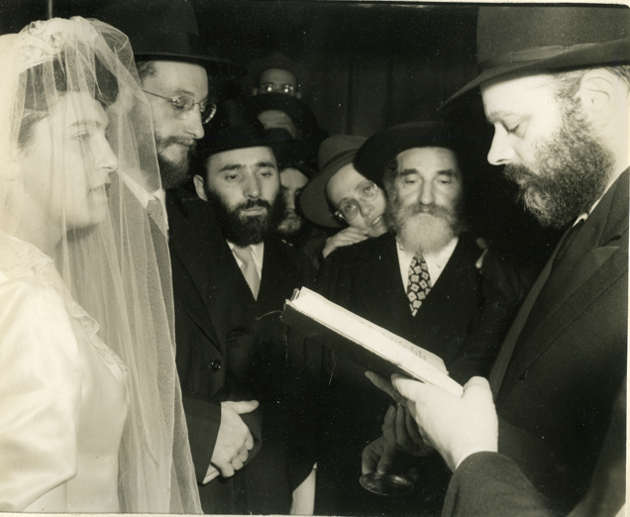
Photo of the chasanah (wedding) of Rabbi Sholom DovBer and Rivka (Rita) Goldshmid of blessed memories with the Lubavitcher Rebbe zt”l serving as the mesader kedushin on 10 Elul 5711/1951.
Reprinted from the Parshas Devorim 5784 email of The Weekly Story by Rabbi Sholom DovBer Avtzon.

